

**NEW DAWN**

**Project Charter**

*Prepared By: Punyaja Mishra*

**Document Control**

**Document Information**

| **©** | **Information** |
| --- | --- |
| Document Id | Project Charter |
| Document Owner | Trent University Enactus Club |
| Issue Date | TBD |
| File Name | New Dawn Project Charter.docx |

**Document History**

| **Version** | **Issue Date** | **Changes** |
| --- | --- | --- |
| [0.1] | 28/09/2022 | Original Template |
| [0.2] | 02/10/2022 | Initial Information with |
| [1.0] |  |  |

**Document Approvals**

| **Role** | **Name** | **Signature©** | **Date** |
| --- | --- | --- | --- |
| Project Sponsor | Trent University Enactus |  |  |
| Project Review Group | Enactus |  |  |
| Project Manager© | Punyaja Mishra |  |  |

**Table of Contents**

**Executive Summary** **2**

**Project Definition** **2**

Vision 2

Objectives 2

Scope 2

Deliverables 3

**Project Organisation** **4**

Customers 4

Stakeholders 4

Roles 4

Responsibilities 5

**Project Plan** **6**

Overall Plan 6

Milestones 6

Financial Plan 7

**Project Considerations** **7**

Risks 7

Assumptions 7

Constraints 7

# 

# Executive Summary

This project is undertaken by Trent University Enactus Club to develop a platform for assisting the homeless population. The group has discovered an opportunity to revive the conditions of the homeless and take steps towards reviving their conditions. This document covers the following sections that outlines the entire project:

* Definition
* Organisation and plan
* Risks and issues
* Assumptions and constraints. ©

# Project Definition

There were thousands of people identified as Homeless in the 2021 Canada Census. For the public to be able to go and help the homeless community, they need to be able to find the details about this population in a much easier way.

The Project “New Dawn” aims to create a platform that will act as a census of the Homeless Population for the public to access and provide assistance. This platform will be a Web Application that will allow the general public to upload information about the homeless people with their details and the location to find them. This will give this community an identity and the general public who truly wishes to help will get a medium to find them and help them.

## Vision

* To deliver an accessible platform to the general public with the ability to upload information about the needy
* To implement the Geolocation feature that delivers the information based on the location
* To procure information about nearby shelters
* To successfully introduce the new Web Application to the public. ©

## Objectives

* To build a new Web Application which allows public to enter and upload information about the homeless
* To allow the users to create an account on the Web Application
* To install Geolocation ability to the Web Application
* To implement feature that allows the users to comment if they helped a particular homeless person
* To embody an easy to navigate User Interface & Design

## Scope

* Lower Poverty rate
* Lower Theft, Robbery and Assault Crime Rate
* One platform to discover homeless population in the nearby area
* Improved efficiency of items usually thrown as waste instead of Donated

## Deliverables

| **Item** | **Components©** | **Description** |
| --- | --- | --- |
| New Platform | * New Website * Accessible to General Public | * Develop new easy to navigate website * Website will be free of charge and easily accessible on all adaptable browsers |
| New Geolocation system | * Location tracking System is Not forced on the users * If allowed by the user. website can track the location of the user * If not allowed by the user, website will prompt them to enter their current city | * The system can track user’s location only if the users give permissions * The system will track the location of the user to find information about the nearby homeless community and shelters * If user does not permit location tracking then they will be prompted to enter the city they are in and they will get search results based on that location |
| New comment section | * Users can comment on the homeless person’s post | * New feature for allowing users to mention their actions they took for helping the homeless person |
| New Feedback Review Page | * Complaints and Feedback WebPage * Complaints and Reviews resolution process | * New website with customer complaints forms, a complaint tracking page * New and Efficient process for resolving complaints and reviews made |

# 

# Project Organisation

## Customers

The Customers or the end-users will be all the General Public that wishes to help the unfortunate by either donating items, money or information (such as about any nearby food-drives, shelters)

## Stakeholders

* Project Manager
* Trent University Enactus Club
* Government Body
* Social Work Department

| **Stakeholder©** | **Interested in** |
| --- | --- |
| Project Manager | Alignment with Project vision and mission |
| Trent University Enactus Club | Alignment with Enactus Board Standards |
| Government Body | Compliance with legislation |
| Social Work Department | Compliance with Social Work codes of practice |

## Roles

* Project Manager
* Project Associates
* Project Financial Manager
* Project Review Group

| **Role** | **Organisation©** | **Resource Name** | **Assignment Status** | **Assignment Date** |
| --- | --- | --- | --- | --- |
| Project Manager | Enactus | Punyaja Mishra | Assigned | 25/09/2022 |
| Project Associate | Enactus | TBD | Unassigned |  |
| Project FinancialManager | Enactus | VP of Finance | Unassigned |  |
| Project Review Group | Enactus | Enactus Club Executives | Assigned | 25/09/2022 |

## Responsibilities

**Project Manager**

Key responsibilities include:

* Documenting the detailed Project Charter and Project Plan
* Ensuring that all required resources are assigned to the project and clearly tasked
* Managing assigned resources according to the defined scope of the project
* Implementing the following project processes: time / cost / quality / change / risk / issue / procurement / communication / acceptance management
* Monitoring and reporting on project performance (re: schedule, cost, quality and risk)
* Reporting and escalating project risks and issues
* Making adjustments to the detailed plan as necessary to provide a complete picture of the progress of the project at any time.

### 

**Project Associate**

Key responsibilities include:

* Undertaking all tasks necessary to build, test and implement the product as allocated by the Project Manager (as per the Project Plan)
* Reporting progress of the execution of tasks to the Project Manager on a frequent basis
* Maintaining all documentation relating to the execution of allocated tasks
* Escalating risks and issues to be resolved by the Project Manager.

©

**Project Review Group**

Key responsibilities include:

* Assisting the Project Financial Manager with the definition of the project vision and objectives
* Undertaking Quality Reviews prior to the completion of each project milestone
* Ensuring that all business risks are identified and managed accordingly

**Project Financial Manager**

Key responsibilities include:

* Managing the Finances and Budget for the project in collaboration with Project Manager
* Maintaining Fundraising Events with the VP of Fundraising

# 

# Project Plan

## Overall Plan

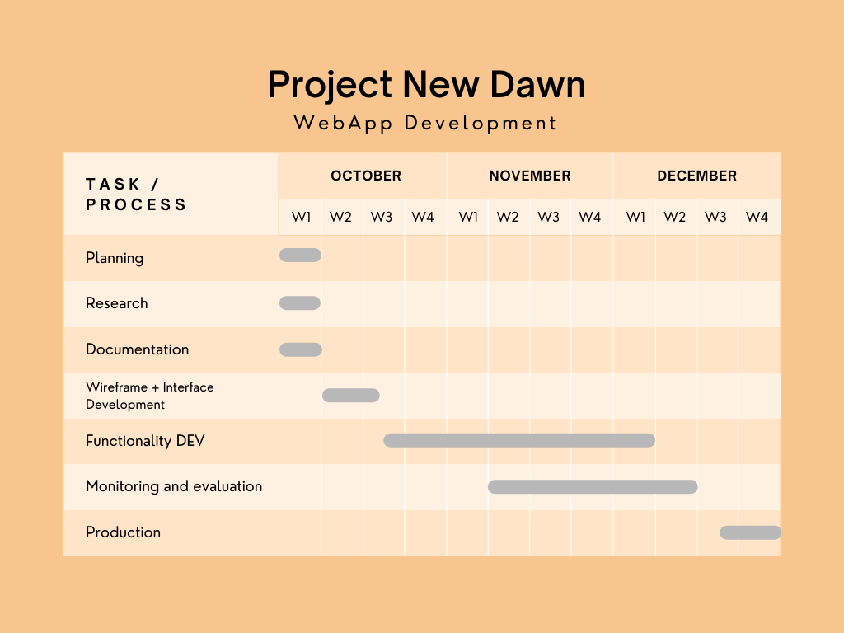

## Milestones

| **Milestone** | **Date©** | **Description** |
| --- | --- | --- |
| Project Documentations | 08/10/2022 | All project planning and research should be reviewed and documented to support the further efficient building process |
| Website Design and Framework | 15/10/2022 | The basic website framework with design elements (HTML< CSS, Php) should be completed to start implementation of functionalities |
| Website Functionalities | 08/12/2022 | Project has a large ongoing scope, therefore basic functionalities should be implemented and tested in Agile manner |
| Website User Acceptance Testing | 15/12/2022 | Final Monitoring, and USer Acceptance Testing of the product by non-developers (other Enactus Teams) to get a “Go” for the deployment |
| Product Deployment | 27/12/2022 | Final Deployment of Website |

## Financial Plan

| **Category** | **Cost©** | **Value** |
| --- | --- | --- |
| Security | * Buy SSL Certificate 1 year * Buy SSL Certificate 5 year | $ 15  $ 35 |
| Database | * Accessing Database for storing User Data of the website | $ |
| Marketing | * Advertising / branding * Promotional materials * PR and communications | $ |

# 

# Project Considerations

## Risks

| **Description** | **Likelihood** | **Impact©** | **Mitigating Actions** |
| --- | --- | --- | --- |
| Inability to control what users post | Medium | High | DEvelop features that can identify unethical and unrelated posts |
| Inability to keep up with technological feature expectations | Low | Very High | Outsource project to appropriately skilled staff with proven industry experience |
| Budget increase with growing scope | Medium | High | Come up with solutions to manage technology wise or financial wise |

## Assumptions

* There will be no legislative, business strategy or policy changes during this project
* Will get support from the Fundraising team on Budgeting
* Trent University IT Team will provide technical support

## Constraints

* The financial budget may vary
* There are limited technical resource available for the project
* The technical solution must be implemented with proper security

# 